Body Condition Scoring and Breeding Readiness in Dairy Goat Doelings: Setting Replacements Up for Lifetime Success

Written by Jennifer Bentley
NE IA Dairy Field Specialist, Iowa State University Extension and Outreach
While raising dairy goats is highly labor-intensive before weaning, what happens between weaning and first breeding has a significant impact on lifetime milk production, reproductive success, and herd longevity. Two of the most important tools for guiding this stage are body condition scoring (BCS) and breeding readiness assessments.
Monitoring body condition and growth ensures that doelings are neither over-conditioned nor underdeveloped when they enter the breeding pen. This article outlines practical strategies for using BCS, growth benchmarks, and management practices to prepare doelings for a healthy first pregnancy and productive first lactation.
Why Body Condition Score Matters
Body condition scoring is a hands-on evaluation of a goat's fat and muscle reserves using a 1–5 scale. While often associated with mature does, BCS is just as important in young stock, providing information that body weight alone can't reveal.
How to Body Condition Score BCS should be assessed monthly from weaning until breeding. Score visually using three key areas to assess muscle fullness and fat cover. Site 1 includes the neck, brisket, point of shoulder, ribs above point of elbow, site 2 includes the loin, rump, hips, and pins, and site 3 includes tail and tailhead area.

Doelings that are too thin may not cycle regularly, have lower or poor conception rates, and struggle to maintain pregnancy. Over-conditioned doelings may deposit fat around developing mammary tissue, potentially reducing future milk yield.

BCS helps identify issues before they affect future development by accurately assessing actual frame growth and muscle development, rather than just weight gain. Doelings that are evenly sized and well-conditioned are easier to manage, cycle more consistently, and conceive more predictably when grouped with a buck.

Target BCS Ranges for Doelings
- Post-weaning: 2.5–3.0
- Breeding age: 2.75–3.25
- Early pregnancy: Maintain 3.0
- Late pregnancy (first fresheners): 3.0–3.5
These targets support optimal frame development, reproductive efficiency, and mammary gland formation during the critical pre-breeding months.

Growth Benchmarks for Breeding Readiness

Doelings should be bred based on size and development, not just age. While most dairy breeds can cycle by 5–7 months of age, that doesn't mean they are physically ready.

Recommended Pre-Breeding Targets
- Age: 7–10 months
- Weight: 60–70% of mature body weight
- BCS: 2.75–3.25
- Frame: Wide, well-developed pelvis; good skeletal growth; strong legs and feet
Breed | Mature Weight (Avg) | 60-70% Breeding Target (Doeling Weight)
Alpine | 135-150 lb. | 78-105 lb.
LaMancha | 130 lb. | 78-91 lb.
Nubian | 135+ lb. | 81-95 lb. (up to 98-123 lb. using full range)
Saanen/Sable | 135-160 lb. | 81-112 lb.
Toggenburg | 120-140 lb. | 72-98 lb.
Oberhasli | 120 lb. | 72-84 lb.
Nigerian Dwarf | 75 lb. | 45-52 lb.
Nutrition to Support Optimal Body Condition
The goal between weaning and breeding is to promote steady, frame-focused growth rather than rapid fat gain. If yearlings are bred at an earlier age, they are still growing quite significantly, and it's almost impossible to overfeed them. However, if they are bred later in life, they often have higher BCS and should be managed to minimize over-conditioning before freshening.
Feeding a high-quality forage (alfalfa or alfalfa/grass mix) will support growth without excessive energy intake. Concentrate feeding should be offered, and the amount will depend on forage quality and breed size, or if doelings are behind in growth. Vitamins and minerals should be offered accordingly to prevent deficiencies and support both fertility and growth. Free choice, clean water will help encourage consistent intake and rumen development.

Assess Breeding Readiness: Beyond Size and BCS

In addition to physical condition, behavioral and reproductive cues help determine breeding readiness.

Reproductive Indicators
- Clear signs of estrus (standing heat, bleating, tail flagging)
- Internal pelvic growth consistent with breed standards
- Appropriate pelvic width (for larger breeds, a two-finger width between hip bones is a helpful early indicator)

Using a Buck or Hormone Synchronization
- Exposure to a buck ("buck effect") can stimulate or synchronize heat cycles.
- Consult with your veterinarian or reproductive specialist about synchronization protocols appropriate for doelings.
Managing the Breeding Season for Success
Key Management Practices
- Group doelings by size before breeding to reduce competition and maintain ample bunk space.
- Verify BCS 4–6 weeks before breeding and adjust diet as needed.
- Ensure vaccinations (CDT), parasite management, and hoof trimming are up to date.
- Avoid breeding very small or immature doelings—this can lead to poor lactation and may increase the risk of dystocia.
Post Breeding Care
- Maintain a steady diet to support early pregnancy.
- Avoid major changes in ration or environment.
- Keep doelings in good BCS (around 3.0) without allowing excessive gain.
Raising quality replacements is one of the most cost-effective strategies for improving herd productivity. Using body condition scoring and growth benchmarks allows producers to:
- Identify nutritional or health issues early
- Breed doelings at the right size and maturity
- Reduce kidding problems
- Set doelings up for a successful first lactation
By consistently monitoring BCS and development from weaning through breeding, producers can make informed decisions to build a healthier replacement herd and ultimately support long-term herd performance and profitability.

Breeding Readiness Checklist
Use this checklist 4–6 weeks before the planned breeding season to ensure doelings are physically mature, healthy, and prepared for a successful first pregnancy.
Age & Growth Benchmarks
- Doeling is 7–10 months old (breed dependent).
- Weight is 60–70% of mature breed weight (e.g., ~80–100 lb. for most standard dairy breeds).
- Growth has been consistent since weaning.
- Frame development is appropriate (wide hips, adequate height, balanced structure).
Body Condition Score (BCS)
- Doeling has a BCS of 2.75-3.25.
- Rib cover: smooth but can still feel ribs.
- Loin: no sharp or overly rounded spine.
- Brisket: minimal fat (not soft or "puffy").
- No signs of being overly thin or over conditioned.

Reproductive Readiness
- Shows regular or observable heat cycles (tail flagging, vocalizing, restlessness).
- Structurally sound for breed and size (wider pins, good frame).
- Comfortable being housed near or exposed to a buck.
- If using AI: doeling tolerates handling and restraint.
Health Status
- CDT vaccine is current (or booster planned 2–4 weeks pre-breeding).
- Parasite management up to date (FAMACHA score checked, Fecal Egg Counts if needed).
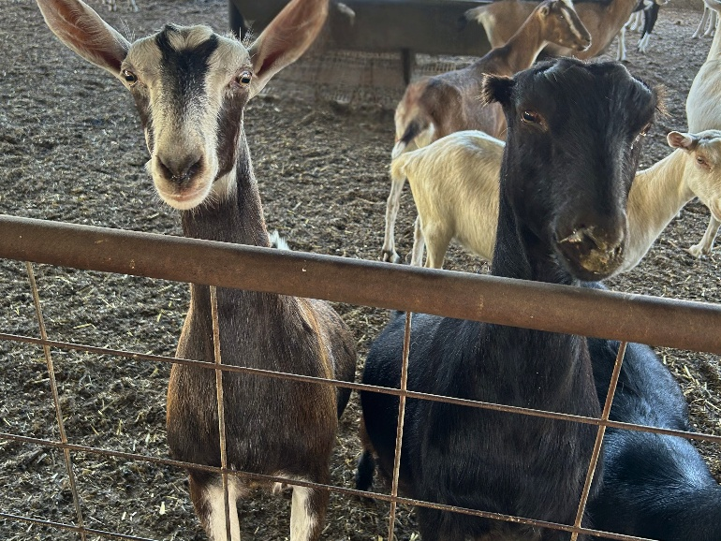
- Hooves are trimmed and soundness checked.
- No signs of respiratory illness, diarrhea, or lameness.

Nutrition & Feeding
- Receiving a balanced ration that supports steady growth, not excessive energy.
- High-quality forage (alfalfa or mixed hay) is available.
- Grain or concentrate offered as needed (½–1 lb/day depending on size and forage quality).
- Adequate mineral status (access to high-quality loose goat mineral).
- Clean, fresh water is always available.

Management & Environment
- Doelings are grouped by similar size to reduce competition.
- Stress is minimized (no major pen changes or mixing of groups, no recent ration changes before or during breeding).
- Pens and housing provide adequate space and ventilation.
- Identification and records are accurate (weights, BCS, health status, sire options).
Buck or AI Method Chosen
- If using a buck:
  - Buck is healthy and fertile, in good condition, and has a recent hoof trim.
  - Breeding groups are planned (size & temperament considered).
- If using AI:
  - Estrus detection plan in place.
  - Synchronization protocol (if any) established with the veterinarian.
  - Appropriate semen storage and handling is important to get the most out of each breeding; store straws in liquid nitrogen tank (frequently monitor level to ensure tank does not run dry), thaw immediately prior to use in a water bath at 95-98F, maintain at that temperature and breed within 15min of thawing.
Breeding-Ready? Final Evaluation
A doeling is considered ready to breed when she meets all the following:
- Age 7–10 months
- Weight ≥ 60% of mature weight
- BCS 2.75–3.25
- Good health with up-to-date vaccinations
- Growing steadily with solid frame development
- Showing signs of estrus
- No signs of illness, lameness, or nutritional deficiency

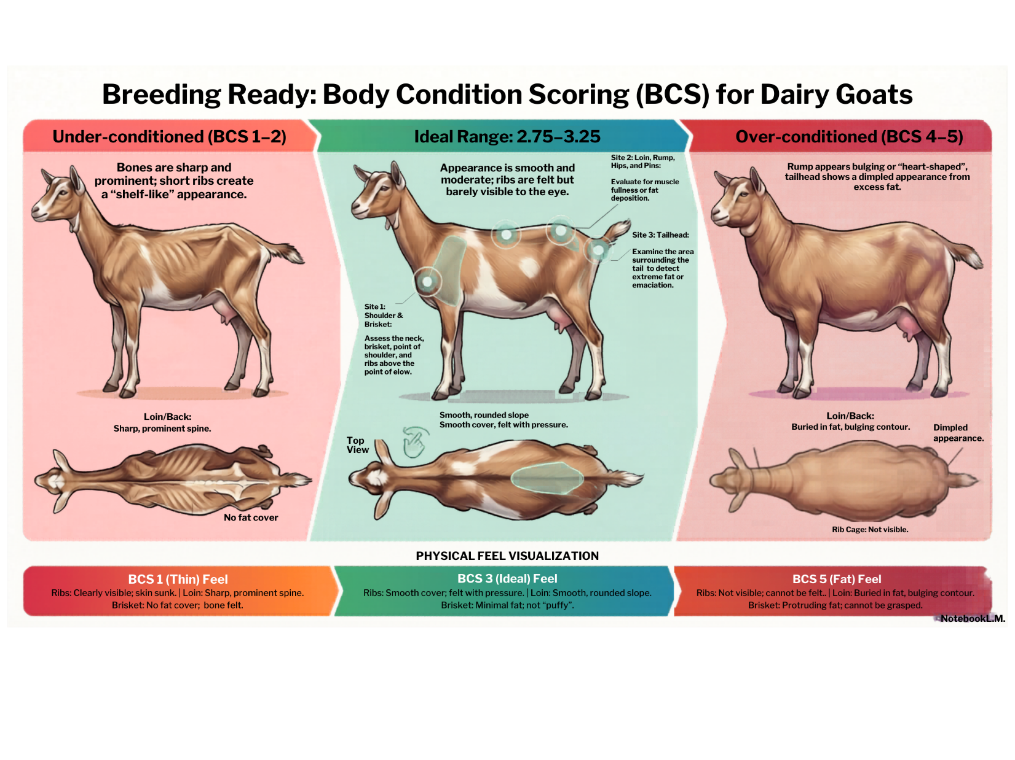

References:
- https://www.nfacc.ca/goats-code-of practice#FappGoats
- https://adga.org/breed-standards/
- https://adga.org/dairy-goat-body-condition-scoring/
- Dairy Goat Production Handbook, published by the American Institute for Goat Research, Langston University

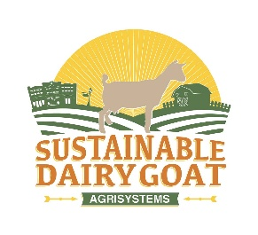
The project is based at Iowa State University, and the work is supported by The Agriculture and Food Research Initiative's Sustainable Agricultural Systems (SAS) program grant no. 2024-68012-41749 from the USDA National Institute of Food and Agriculture.

