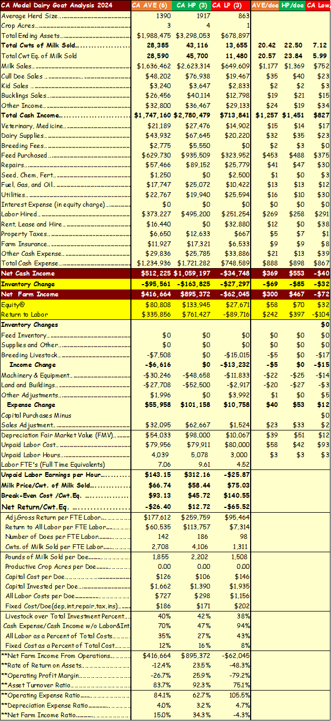
The Profitability of the California Dairy Goat Industry Study in 2024
Six farms were financially analyzed in California (CA) using 2024 data. To the right is a table displaying incomes, expenses, and per doe metrics for the average (AVE) of the six farms; for the Higher Profit (HP) three farms; and for the Lower Profit (LP) three farms. These dairy goat farms would be considered larger for most areas of the country with the herd size being 1,390 for the AVE farm; 1,917 for the HP farms and 863 for the LP farms. The total ending assets was approximately $2 million for the AVE farm; $3.3 million for the HP farms; and $0.7 million for the LP farms.
At first glance, it would seem the average herd size of the HP farms correlate to higher profitability but know the smallest farm in the HP group was around 500 does and the largest farm in the LP group was around 2,500 does. Also, know that in a small sample size such as this, one farm can shift the average quite dramatically.
The focus on this analysis will be on a per doe basis on the right side of the table as per doe benchmarks are more easily applied to any given herd.
Milk sales per doe for the AVE farm was $1,177; for the HP farms was $1,369; and for the LP farms was $752. The addition of sales of cull does, doelings, bucklings and other incomes gave total cash incomes per doe for the AVE farms of $1,257; for the HP farms of $1,451; and for the LP farms of $827. The major difference between the HP and LP farms was on the income side of the equation.
The major expense was feed. Lower feed quality and feed wastage seemed more evident on the LP farms. The HP farms invested in better forage and more efficient feeding systems. The feed costs per doe for the AVE farm was $453; the HP farms was $488; and the LP farms was $375.
The cash expenses per doe were surprisingly very similar with the AVE farms at $888; the HP farms at $898; and the LP farms at $867. So, again the profit difference stems mainly from the milk and livestock sales part of the equation, not the expense side.
Net Cash Income per doe for the AVE farm was $369; for the HP farms was $553; and for the LP farms was -$40. After inventory changes, which was depreciation for the most part, the Net Farm Income per doe for the AVE farm was $300; for the HP farms was $467; and for the LP farms was -$72. The HP farms had $539 more net farm income per doe than the LP farms, again, most of which came from income, not expenses.
After a 4% equity charge per doe across all assets (whether owned or borrowed), of $58 for the AVE farm; $70 for the HP farms; and $32 for the LP farms, the Return to Labor per doe for the AVE farm was $242; for the HP farms was $397; and for the LP farms -$104. The HP farms had $501 more return to labor per doe than the LP farms. If the net return to labor is divided by the unpaid labor hours the AVE farm earned $143.15 per hour; the HP farms earned $312.16 per hour; and the LP farms earned -$25.87. These CA dairy operations employ lots of hired labor averaging $269 per doe.
Total cost of production analysis shows a pay price per cwt. of milk sold for the AVE farm of $66.74; for the HP farms of $58.44; for the LP farms of $75.03. This pay price needs discussion as many of these farms processed their own milk and picked a price the processing enterprise bought milk from their production enterprise.
The total cost of production per cwt.eq. for the AVE farm was $93.13; for the HP farms was $45.72; and for the LP farms was $140.55. The cost of production for the HP farms was less than 1/3 that of the LP farms even with a 28% higher pay price for the LP farms. This plays into the net return per cwt.eq. for the AVE farm of -$26.40; for the HP farms at $12.72; and for the LP farms at -$65.52.
Labor Efficiency and milk production often go hand in hand as the top two measures in dairy goat profitability. The number of does per Full Time Equivalent (FTE equals 3,000 hours worked annually) for the AVE farm was 142; for the HP farms was 186; and for the LP farms was 98. The labor efficiency per doe was just 10 does shy of being double that of the LP farms.
Targeting milk production efficiency relative to labor shows the cwts of milk sold per FTE for the AVE farm was 2,708; for the HP farms was 4,106; and for the LP farms was 1,311. Annual pounds of milk production per doe for the AVE farm was 1855; for the HP farms was 2,202; and for the LP farms was 1,508.
As a sidenote, the HP farms were very close to meeting all the profit benchmarks for a dairy goat herd:
- > $1,000 in milk sales per doe
- = 150-200 does per FTE Laborer
- > 2,300 pounds of milk per doe annually
- > 400,000 pounds of milk sold per FTE
The HP farms were just slightly short in pounds of milk sold per doe but made up for it with 186 does per FTE allowing them to surpass the 400,000 milk sold per FTE. All labor costs per doe also showed a dramatic difference with HP farms at $298 and the LP farms at $1,156. All Labor Costs as a percent of Total Costs was 43% for the LP herds and 27% for the HP herds. Again, labor efficiency and milk production per doe and per FTE laborer are of most importance.
Capital costs (consisting of depreciation and interest/equity charges) are also important as the LP farms are significantly more heavily invested per doe with the HP farms at $106 and the low profit farms at $146. The LP farms have 38% more capital costs per doe than the HP farms. Addedly, the HP farms have $1,390 invested per doe while the LP farms had $1,935 invested per doe. The LP farms have $31 more Fixed Costs per Doe which consist of depreciation, interest, repairs, taxes and insurance.

The Profit Equation is depicted by the following financial equation and financial ratios:
Profit = (Price – Cost) x Volume
or ROA = OPM x ATO
Where ROA is return on assets, OPM is Operating Profit Margin, and ATO is Asset Turnover Ratio.
The ROA for the AVE farm was -$12.4%; for the HP farms was 23.5%; and for the LP farms was -48.3%. The ROA is an all-inclusive profit measure that can be compared to returns of other money uses and investments. The HP farms are financially healthy while the LP farms are at risk of eroding equity quickly.
OPM defines profit per dollar of output and the AVE farm had an OPM of -26.7%; the HP farms had an OPM of 25.9% meaning for each dollar of sales, the HP farms kept about a quarter in their pocket for profit. The LP farms had an OPM of -79.2% meaning these farms need some serious financial and production changes.
The ATO defines how long it takes to gross enough income to pay for all the assets on the farm. The ATO for the HP farms was 92.3% and for the LP farms was 75.1%. Both groups had healthy ATO ratios for dairy goat operations.
Overall, there is a very dramatic difference between the HP and LP dairy goat herds in CA. Milk production per goat and per FTE Laborer were the two most important profit factors followed by capital costs per doe.

Management Advice to the CA Dairy Industry
Closing the income gap between HP farms and LP farms would require more attention to genetics, feed quality, feed bunk design, kid management, ventilation and labor efficiency. Milk production per doe is a combination of both better genetics and higher feed quality which may increase expenses but with better genetic does, it tends to increase profits.
Feed bunk design issues were noted on many farms. Most issues were high feed losses from in-pen type round bale type feeders. Most issues with lower dry matter intake were from fence-line feed bunks that created “throat-cut” or limited intake. Thus, proper feed bunk design becomes critical to minimizing feed wastage and improving dry matter intake.
Kids survival and sales represent another important opportunity to improve farm income. This not only generates revenue from selling replacement doelings and bucklings but reduces expenses with purchasing replacement does. High kid mortality or poor growth can delay and reduce future milk productivity and milk income. Key areas to evaluate within a kid rearing program include:
- Proper dry doe management to ensure optimal body condition at kidding.
- Effective colostrum management for adequate intake at birth
- Sanitation of feeding equipment to reduce pathogen load
- Hygiene of kidding areas and kid pens that are clean, dry, well-ventilated, and provide shelter from cold drafts and weather
- Kid health protocols targeting common diseases such as coccidiosis, pneumonia, E. coli, salmonella, etc.

Inadequate ventilation increases humidity and ammonia buildup, stressing goats and predisposing them to illness. Proper airflow reduces respiratory disease risk and maintains milk production.

Lastly, labor efficiency is highly correlated to the milking parlor and milking management. Low-cost milking parlors can often be updated without major investment to allow one person to milk 100 plus does per hour. This would better allow the management of 175 plus does per person and allow labor to be less than 20% of total expenses.

Authored by:
Jenn Bentley, Dairy Specialist, Iowa State University Extension and Outreach
Roselle Busch, DVM, Associate Specialist, ANR Veterinary Medicine, UC Davis
Larry Tranel, Dairy Specialist, Iowa State University Extension and Outreach

This work is supported by the Sustainable Agricultural Systems project award number 2024-68012-41749 from the U.S. Department of Agriculture’s National Institute of Food and Agriculture.

